Populating Complex Intersection Features

Features and Attributes defining Complex Intersections

Minimum attributes:
Nodes
Complex
IsPrincipal
IntersectionID
IntersectionNodeCount
IntersectionLegCount
IntersectionLegExceptions
NodeLegs
Complex
IsPrincipal
IntersectionID
IntersectionLegID

Additional attributes:
Principal Node
Major_LegID
Major_LegID_2
Minor_LegID
Minor_LegID_2
Minor_LegID_3
Principal NodeLegs
MajorMinor
MajorMinorType
Major1 and Minor1 NodeLegs (only if Major1 or Minor1 doesn’t correspond to Major_LegID or Minor_LegID)
TWN_MM_Alt_LegID
TWN_MM_Alt*
AADT_Alt_LegID
AADT_Alt_Adjust (if necessary)
AADT_Alt*
*can be autopopulated eventually if Alt_LegIDs set correctly

Features and Attributes defining Complex Intersections (additional details)
- Principal Node
  - Complex = 1
  - IsPrincipal = 1
  - PrincipalNodeID = NodeID of the intersection’s Principal Node
  - IntersectionID = PrincipalNodeID *(any reason to keep both of these?)
  - IntersectionNodeCount = number of Nodes participating in the generalized intersection
  - IntersectionLegCount = number of Principal NodeLegs in the generalized intersection (i.e. should represent the number of generalized approaches)
  - IntersectionLegExceptions = number of generalized approaches that are not represented in the data (flag for discrepancies between IntersectionLegCount and IntersectionGeometry)
  - Major_LegID = generally the Principal NodeLegID of the approach with highest AADT
  - Minor_LegID = the NodeLegID of the intersecting approach (i.e. not straight thru-lanes) with the highest AADT
  - Major_LegID_2 = the Principal NodeLegID of the approach with the Major approach’s thru-lanes
  - Minor_LegID_2 = the Principal NodeLegID of the Minor approach’s thru-lanes
  - Minor_LegID_3 = the Principal NodeLegID of any remaining approaches (generally lowest AADT)
- Non-Principal Nodes (2 or more)
  - Complex = 1
  - IsPrincipal = 1
  - PrincipalNodeID = NodeID of the intersection’s Principal Node
  - IntersectionID = PrincipalNodeID *(any reason to keep both of these?)
  - IntersectionNodeCount = number of Nodes participating in the generalized intersection
  - IntersectionLegCount = number of Principal NodeLegs in the generalized intersection (i.e. should represent the number of generalized approaches)
- Principal NodeLegs
  - Complex = 1
  - IsPrincipal = 1
  - IntersectionID
  - IntersectionLegID = NodeLegID of the Principal NodeLegID representing that generalized approach
  - IntersectionLegCount = number of Principal NodeLegs in the generalized intersection (i.e. should represent the number of generalized approaches)
  - MajorMinor = Indicates whether the approach is part of the intersection’s Major Route or Minor Route *(Maybe this isn’t necessary?) [Major, Minor]
  - MajorMinorType = More specific indicator than MajorMinor, with numbers reflecting whether an approach is the first or second (or third) Major or Minor approach [Major1, Major2, Minor1, Minor2, Minor3]
- Non-Principal NodeLegs
  - Complex = 1
  - IsPrincipal = 0
  - IntersectionID = NodeID of the intersection’s Principal Node
- Major1 and Minor1 NodeLegs
  - Only populate if Major1 or Minor1 legs do not correspond to Major_LegID or Minor_LegID
  - TWN_MM_Alt_LegID = NodeLegID of the most appropriate NodeLeg for obtaining the intersection’s measure along the Major or Minor route (depending on whether the target NodeLeg is Major or Minor)
  - TWN_MM_Alt = TWN_MM value from the non-principal NodeLeg defined by TWN_MM_Alt_LegID
  - AADT_Alt_LegID = NodeLegID of the most appropriate NodeLeg for obtaining the intersection’s AADT value along the Major or Minor route (depending on whether the target NodeLeg is Major or Minor)
  - AADT_Alt_Adjust
    - AADT_Alt_Adjust = 1 (or Null) -> AADT_Alt = AADT_Alt_LegID’s AADT value
    - AADT_Alt_Adjust = 2 -> AADT_Alt is the sum of this leg’s AADT and AADT_Alt_LegID’s AADT
    - AADT_Alt_Adjust = 5 -> AADT_Alt is half the value of AADT_Alt_LegID
  - AADT_Alt = AADT value for the generalized approach represented by the principal NodeLeg (according to the formula indicated by the value of AADT_Alt_Adjust).

RPC Intersection Edit – ArcGIS Online Group
https://vtrans.maps.arcgis.com/home/group.html?id=8de7e8e8ea4d455d9593d1d563e03eb7
- This group was set up so that non-VTrans users could be given password-only access to editable versions of the Nodes and NodeLegs data
- The group also contains several types of documentation, found more easily by clicking on “View all group content”, and then clicking on the “Documentation” in the list of Filters on the left.

Web Map for editing Intersection Data
New (11/1/2022): https://vtrans.maps.arcgis.com/home/webmap/viewer.html?webmap=e913647125c848f7a3174e65c637980c
Original: https://vtrans.maps.arcgis.com/home/webmap/viewer.html?webmap=c146207e592347ca904995ae9caaa185
- Only the attributes of the Nodes and NodeLegs layers are editable. The features and other layers in this map are not editable. If there are issues, let Kerry or Johnathan know.
- Edits can only be made when the web map is in “Edit” mode, entered by clicking on the Edit tab to the right of the Details tab, or by clicking “Edit” at the bottom of a pop-up window.
- Edits are saved automatically, and the web map remains in Edit mode until the Details tab is selected, returning the web map to it’s normal viewing mode.
- Please let Kerry know if making a significant number of edits, as it is necessary to run a script to post the edits to the base version of the data. Any changes made by the Mapping Section are visible in the web map immediately, but we will not see the edits in our version of the data until the edits are reconciled and posted to the base version. We currently check to see if there are new edits about once a week, and before we do bulk calculations. It is not a problem if a few minor edits wait a few days to be reconciled and posted to the base version.
- Two new layers added 11/1/2023:
  - NodeLegs – Ranked MajorMinor: Similar to NodeLegs MajorMinor, but reflect the field “MajorMinorType” instead of “MajorMinor”, where Major1 and Minor1 legs have wider line symbology than Major2, Minor2, and Minor3 legs (but with the same MajorMinor colors) Can be used as an alternative to NodeLegs MajorMinor.
  - NodeLegs – TWN_MM_Alt_LegID Populated: Only symbolized if the TWN_MM_Alt_LegID field is populated, which should occur with Major1 or Minor1 Nodelegs if the correct Major or Minor mileage is not represented by the Major1 or Minor1 NodeLeg.
- Feel free to save your own customizable copy of the web map, or to suggest improvements to the existing web map.

Editing Workflow
- Find a potential Complex Intersection to review and define it as Complex or Simple:
  - With the map options showing the Details pane, click on the Potentially Complex Nodes layer in the web map VTrans Intersections – Complex Intersection Edits and then click on the table symbol to open the underlying table.
  - Click on a row in the table to select that feature, then click on the Menu symbol (three horizontal bars) in the top right corner of the table, and select “Center on selection.”
  - Alternatively, it is possible to move the Potentially Complex Nodes layer above all the other layers listed in the Content pane of the map. Then this layer’s symbology can be seen, making it possible to find the features visually instead of using the table.
- Editing mode in a web map
  - It is possible to start editing attributes by selecting feature(s) in the web map to open the pop-up window and to then click on “Edit” at the bottom of the pop-up window.
  - Alternatively it is possible to start editing by clicking the Edit tab to the right of the Details tab in the top left corner of the web map window.
  - Regardless of which method is used to start editing, you will see that the Edit tab is underlined when editing is possible, and the information in the pop-up window is editable. You will remain in editing mode (and be able to select and edit additional features) until you click the Details tab to return to the normal web map view.
  - Note that multiple overlapping/nearby features (including Nodes, NodeLegs, and RDSMALL_ARC Nightly) might be selected with a single click, but only one will be shown at a time in the pop-up window. The text at the top of the pop-up window, e.g. “(1 of 8)” will indicate how many features are selected and which one is currently shown. Clicking on the tiny arrow(s) to the right of that text near the top right corner of the pop-up will show the attributes of other selected features.
- Determine which Nodes and NodeLegs participate in the Complex Intersection
  - Complex = 1
- Identify the Principal Node (one per intersection) and Principal NodeLegs (one per generalized approach)
  - IsPrincipal = 1
- Remaining Non-Principal features
  - IsPrincipal = 0
- Populate unique ID values (IntersectionID and/or IntersectionLegID) on all intersection features
- Populate Nodes
  - IntersectionNodeCount (total number of Nodes)
  - IntersectionLegCount (number of Principal NodeLegs)
- Populate Principal Node
  - Major_LegID
  - Major_LegID_2
  - Minor_LegID
  - Minor_LegID_2
  - Minor_LegID_3
- Populate Principal NodeLegs
  - MajorMinor
  - MajorMinorType

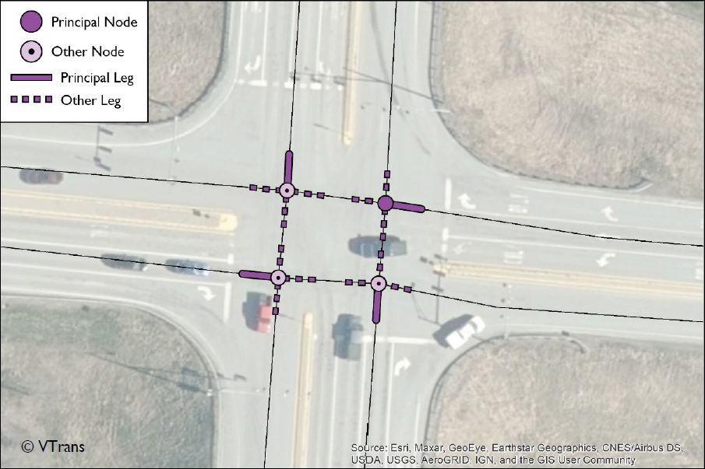

Define Complex Intersection Example:

White River Jct roundabout on US-5 at S0325:
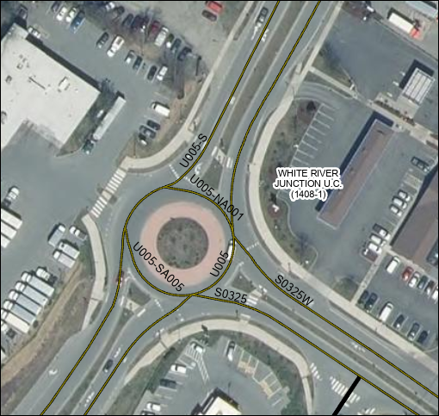

I’ve assumed here that the method of defining a roundabout is Major and Minor attributes AADT is the same as for any other complex intersection.

Principal Node
- I picked Node 51454 to be the principal Node because it intersects the inventory direction carriageway of both the major and the minor routes (i.e. U005 and S0325 instead of U005S or S0325W)
- Complex = 1, IsPrincipal = 1, IntersectionID = 51454, IntersectionNodeCount = 4 (3 general approaches in the road centerline data, plus one commercial approach that isn’t digitized), and IntersectionLegExceptions = 1 (one commercial approach isn’t digitized in the road centerline data)
Non-principal Nodes
- All have Complex = 1, IsPrincipal = 0, IntersectionID = 51454
Principal NodeLegs
- I picked Nodelegs 128569, 154005, and 154009 to be the principal nodelegs because they are represent the direction of traffic towards the roundabout from each direction. (All other NodeLegs have Null IntersectionLegID). Complex
- The thicker dark blue NodeLeg symbology tells you which leg has MajorMinorType = Major1, the thinner dark blue NodeLeg symbology tells you which leg has MajorMinorType = Major2
- 128569: MajorMinorType = Major1, AADT_AltLegID = 108599 (Because the AADT on this other NodeLeg is also needed to determine the appropriate “generalized” AADT that represents both carriageways of the approach to the roundabout from the south), AADT_Alt_Adjust = 2 (a value of 2 indicates that the appropriate “generalized” AADT value is obtained by adding the AADT of the principal NodeLeg and the AADT of the AADT_Alt_LegID (i.e. if AADT values are separated out for each carriageway, they have to be added to represent that approach as a whole).
- 154005: MajorMinorType = Major2, AADT_Alt_LegID = 154008 because it has the relevant AADT value for the approach from the north, AADT_Alt_Adjust = 1 because a value 1 indicates that we simply use the AADT value of the AADT_Alt_LegID because it already represents both carriageways from the north, TWN_MM_Alt_LegID = Null because we get the measure of the intersection from the Major1 NodeLeg (not Major2 NodeLeg).
- 154009: MajorMinorType = Minor1, AADT_Alt_LegID = 51454, AADT_Alt_Adjust = 1 (or Null) because a value 1 (or Null) indicates that we simply use the AADT value of the AADT_Alt_LegID because it represents AADT of both carriageways from the east combined, TWN_MM_Alt_LegID = 128575 because that is the NodeLeg that determines the measure along the inventory direction carriageway (In this case the TWN_MM value is zero at both NodeLegs, but sometimes they might differ, and in such cases the inventory direction measure is the important measure. (For example, the measures for U005 are different on NodeLegs 108599 and 128569, but we already chose the inventory direction NodeLeg as the principal leg so an AADT_Alt_LegID wasn’t needed anyway). Because the Route code of this principal NodeLeg is for the non-inventory direction of the route (S0325W instead of S0325), Extraction methods (ETL process) should look up the Route code for the inventory direction carriageway (or potentially add field for Route_Alt_LegID)
Non-principal NodeLegs
- All have Complex = 1, IsPrincipal = 0, IntersectionID = 51454

Image of roundabout showing key ID values:
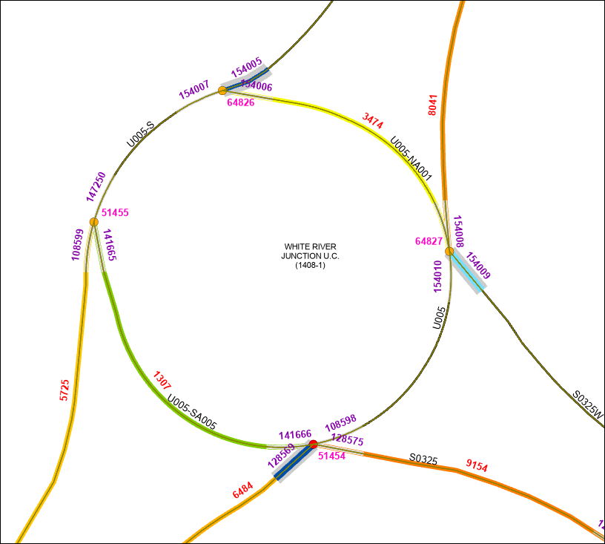
Label colors:
NodeID – Pink
NodeLegID – Purple
AADT – Red
Route Codes – Black
NodeLeg color:
Principal Major Nodeleg(s) – Dark blue
Principal Minor Nodeleg(s) – Light blue
NodeLeg line thickness:
Principal Nodelegs – Thick line symbology
Non-principal Nodelegs – Narrow line symbology
AADT Symbology:
Road centerline colors reflect AADT values (also indicated by red labels)

